# CS 255 System Design Document Template

## UML Diagrams

### UML Use Case Diagram

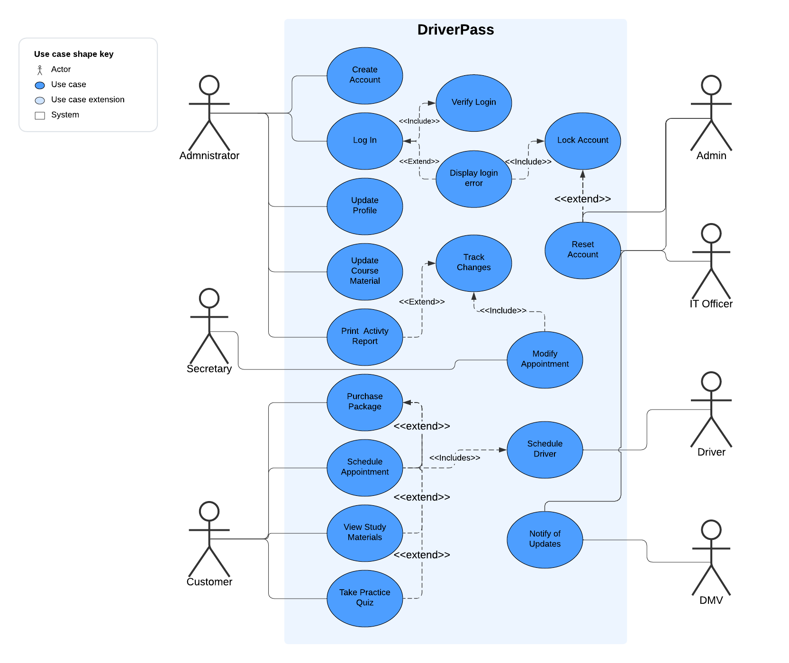

### UML Activity Diagrams

### UML Sequence Diagram

### UML Class Diagram

## Technical Requirements

*[Based on the diagrams you have created, describe the technical requirements of your system. These requirements should address the required hardware, software, tools, and infrastructure necessary for your system design.]*

* Hardware
  + Client:
    - Dedicated Server
    - Network Cables and associated equipment
    - Computer
      * Monitor
      * Keyboard
    - Power Source
    - Internet Access
  + User
    - Computer, laptop, mobile phone, or tablet
    - Internet Access
    - Power source
* Software
  + Client
    - Windows operating system
    - Web Browser
  + User
    - Windows, Linux, or Mac operating system
    - Web Browser
* Tools
  + Computers
  + Programming Software
  + Internet Access
  + Administrative and Security tools
* Infrastructure
  + Cloud-based server location